------------------------------------------------------------------------------------------------------------------------
MicroHOWTO: VISUAL GUIDE to making hidden files visible
This tutorial explains:
- How to make hidden folders visible on your computer.
- How to make hidden folders invisible again.
- Why keeping hidden folders hidden, is the safest option when you are not working on the files inside these hidden folders.
------------------------------------------------------------------------------------------------------------------------
Instructions
Hiding specific folders in Linux Mint is achieved by placing a dot (.) in front of their name.

- e.g. renaming the folder local to .local will mark this folder as hidden and render it invisible the next time you open its directory. This does not work on the desktop (Ref. 1)

------------------------------------------------------------------------------------------------------------------------
1). Make hidden folders visible
a). Double click (or Right-click – Open) on the Home icon on your desktop.
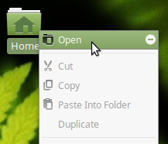

You should see something like this.

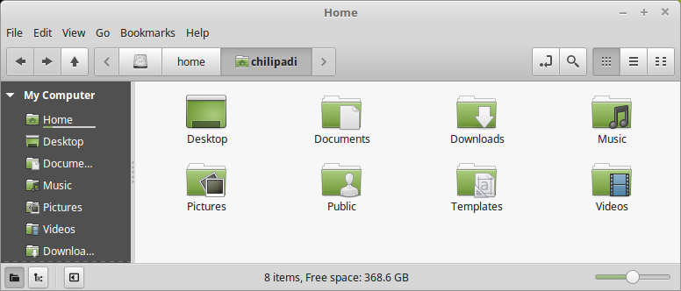

b). Now press the Ctrl key and the H key on your keyboard at the same time.

- All the hidden folders in the Home directory (Ref. 2) should now be visible.


- Hidden folders can be easily identified because they always start with a dot (.)

e.g.

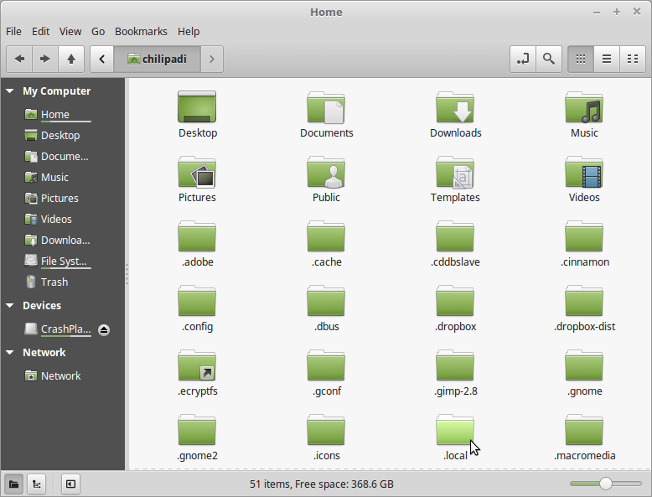
------------------------------------------------------------------------------------------------------------------------
2). Make hidden folders invisible again
To make hidden files invisible again, simply press the Ctrl key and the H key on your keyboard at the same time.

You should see something like this (i.e. no hidden folders visible).

------------------------------------------------------------------------------------------------------------------------
3). Why you should keep hidden folders hidden
A lot of programs that you run on your computer, store hidden files locally on your computer.

The Musique music player for example stores album cover images that it needs to display to the user, in the .local hidden folder.

As long as the .local folder is hidden, there is no danger of you accidentally deleting or corrupting the files stored in this folder.

-----------------------------------------------------------------------------------------------------------------------
References
- Hide files in Linux Mint/Ubuntu (Ref. 1)
https://www.faqforge.com/linux/hide-files-in-linux-mintubuntu/
- Is "Directory" or "Folder" the Correct Term? (Ref. 2)
http://goinglinux.com/articles/DirectoryVsFolder.html

-----------------------------------------------------------------------------------------------------------------------

